- Create an account with USASoftball. Verify your email. (if current user, log in to your account, and skip verification. If your login does not work, you must re-register-your info will re-populate)
- Once email is verified, go to dashboard, and click the my family tab. 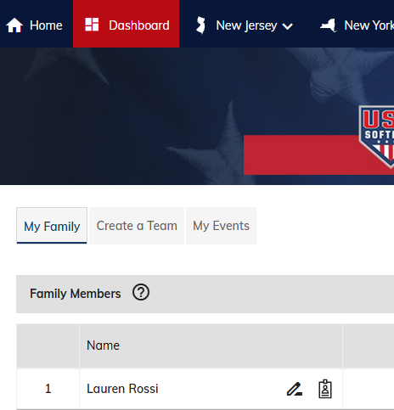
- Click compliance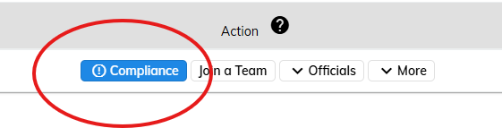
Click Background Check, purchase background check. 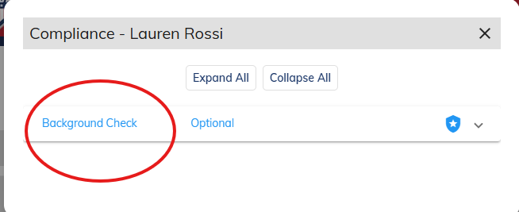

- Once payment is confirmed, Click the orange button to be redirected to NCSI website to complete background check.
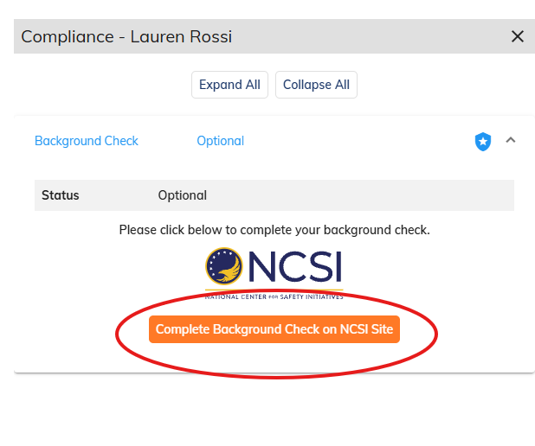
- Complete questionnaire, and submit. Note Confirmation number.
- Once background check is cleared, screenshot passing image (make sure name is included in the image)
- Once background check is cleared, go back to the compliance tab, and complete the safesport course. If you have done courses prior, it will default to a refresher, or the main course. Once course is completed, download certificate.
- Email both the background check, and Safesport certificate to oldbridgegsl@gmail.com

